Documentation:

User Details(web application)

User details is web application in MVC by consuming web api .As functional flow we can add the new user, update any user & remove any particular user according to choice.

There are Four Basic Functionality :

1.Get all user details.

2.Add new user.

3.Update user.

4.Remove User.

Flow :

1. To get all user data :

Steps:

1.After Run the application got the following output:

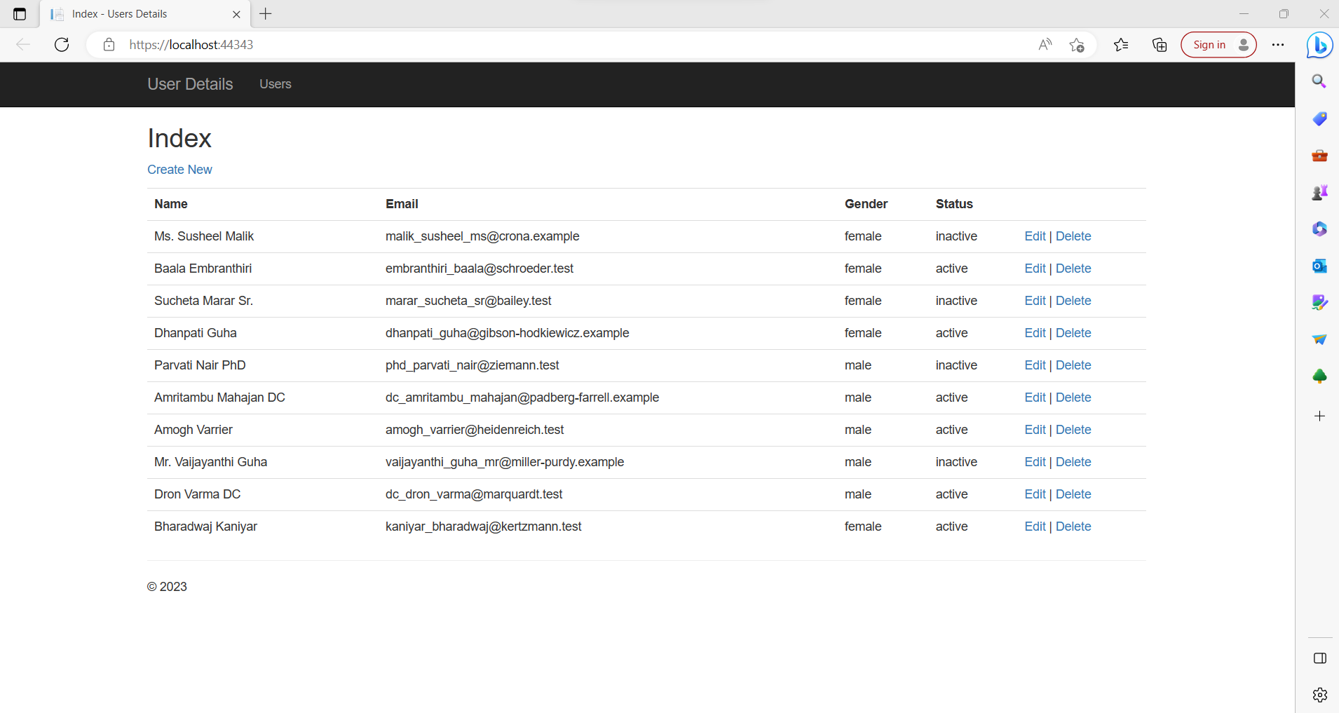

2.Add new user:

Steps:

1.click on **Create New** link.

2.Add the details of user.

3 click on **Create** button.

1.

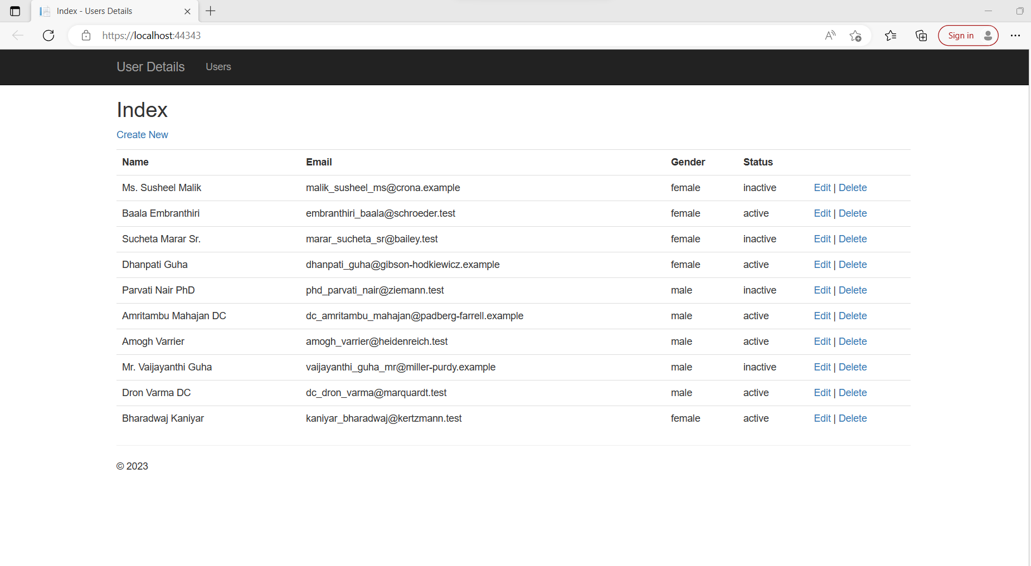

2.

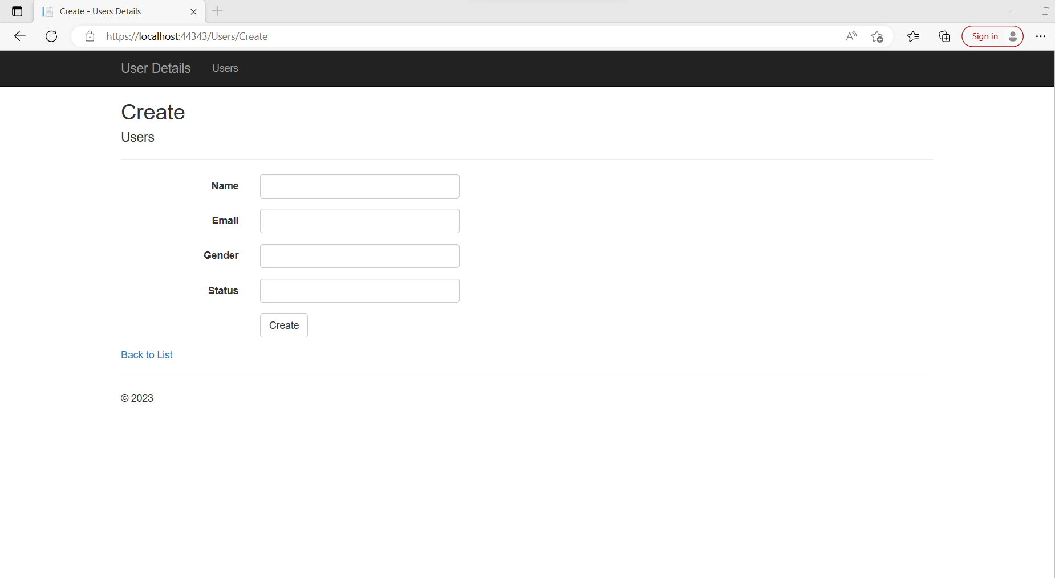

3.If you never fill all the details validation shown as below:

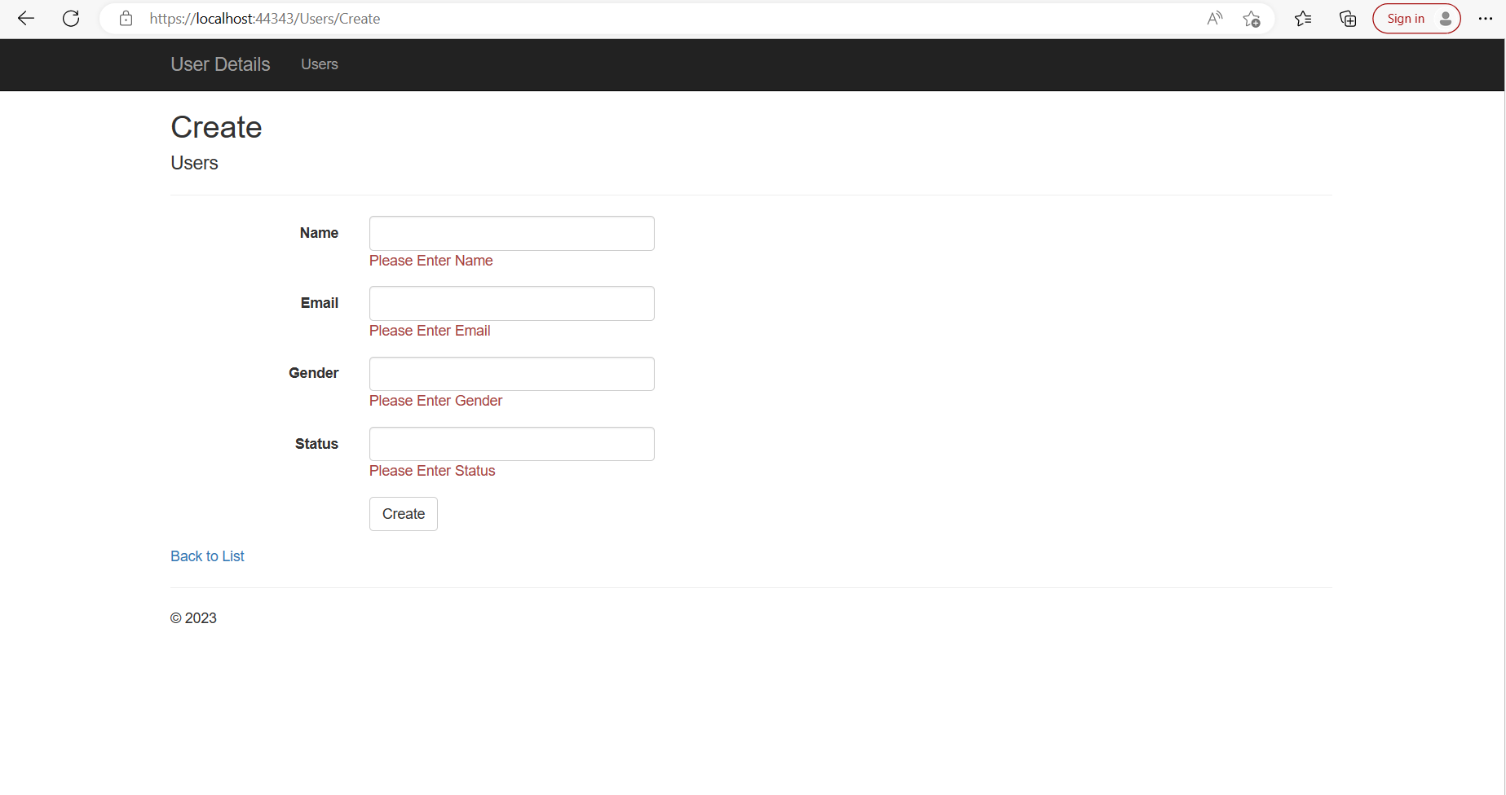

**3.Update the User:**

**Steps:**

1.click on Edit.

2.update the details of user.

3.click on save button.

1.

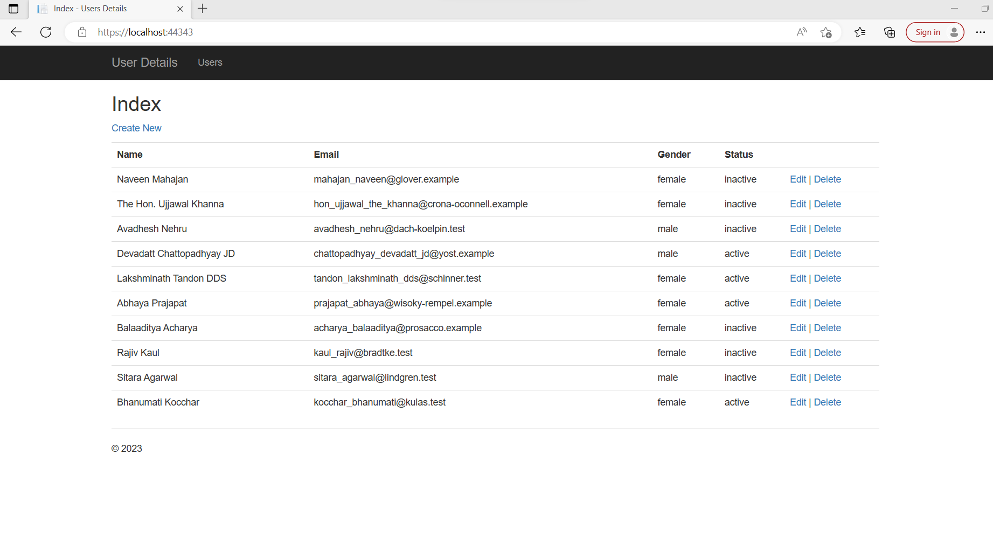

2

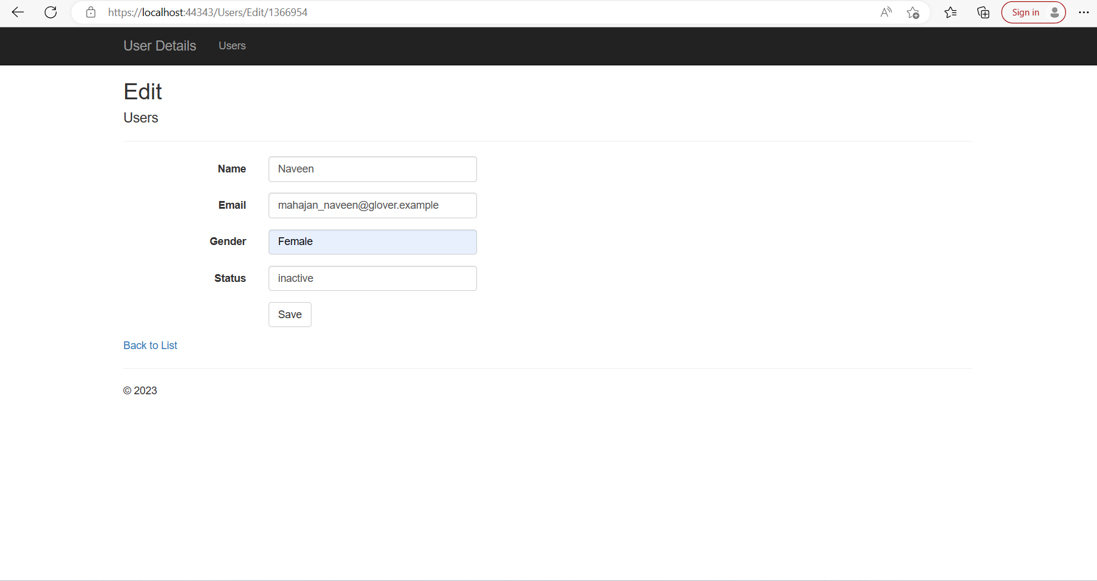

3.update record shown as below:

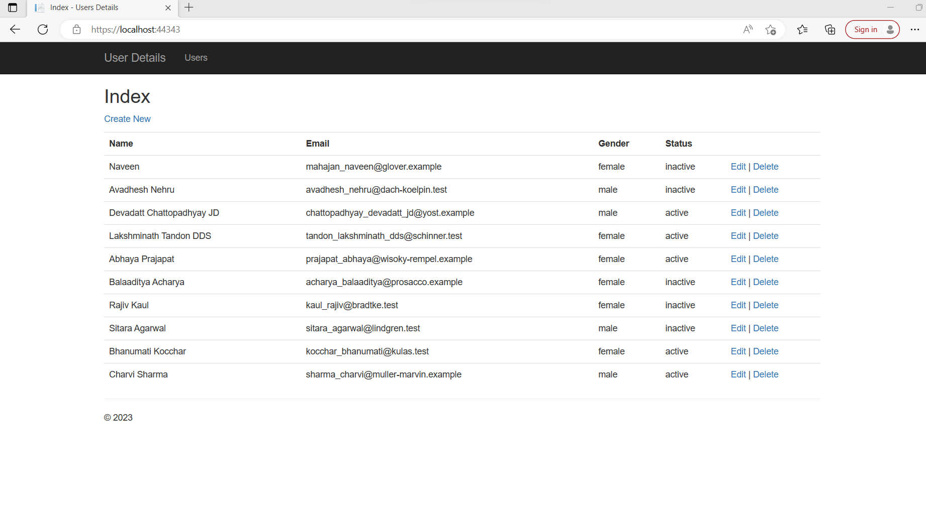

**4. Remove the details of user:**

**Steps:**

**1.**click on delete .

**2.**click on yes confirmation message ”are you sure you wants to delete this”

1.

1. 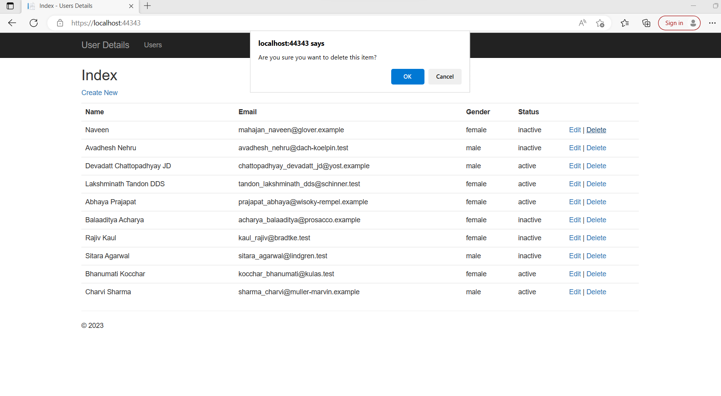
2. user deleted successfully as show below :

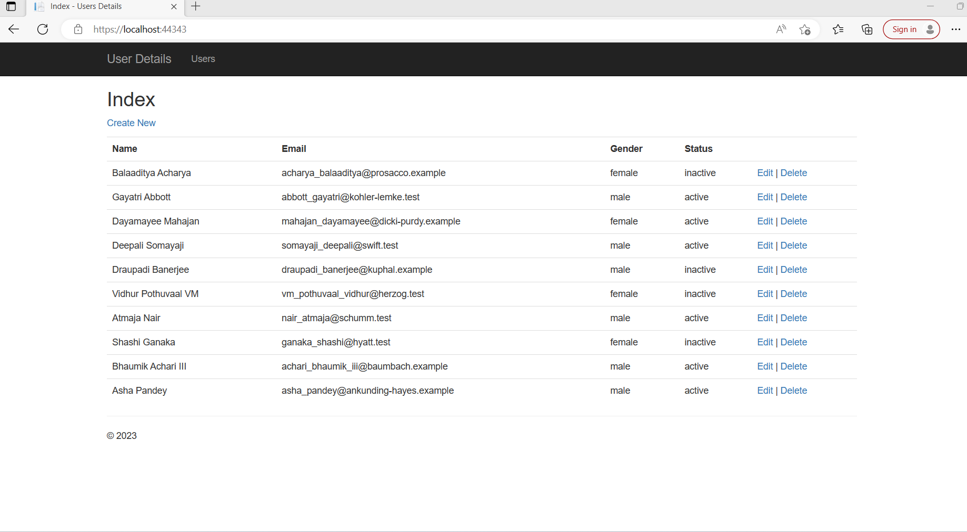

5.Unit tests :

Steps:

1.Build the application.

2.Click on Test menu.

3.Click on” run all tests”

